**PROJECT REPORT TEMPLATE**

1. **INTRODUCTION**

**Edu connect learning centers**  are independent academic units within colleges and universities that exist to provide support services for faculty, to help teaching faculty to improve their teaching and professional development. Edu connect learning centers also routinely provide professional development for graduate students as they prepare for future careers as teaching faculty. Some centers also may provide learning support services for students, and other services, depending on the individual institution. Teaching and learning centers may have different kinds of names, such as faculty development centers, teaching and learning centers, centers for teaching and learning, centers for teaching excellence, academic support centers, and others; a common abbreviation is TLC.

Teaching and learning centers typically offer professional development services for faculty, particularly to help them improve their teaching and professional careers. Depending on the institution, these may be optional for professors, or required for new professors or those facing difficulties in teaching performance. Some universities in the American system may require graduate teaching assistants who teach university courses to participate in training or coaching programs. Such centers also work to promote more modern teaching methods, discussion, and institutional changes in teaching practices and in the academic environment.

Other services may include workshops, brown bags meetings, or consultation services in other areas of professional development for teachers. Topics in teaching skills can be addressed, such as improving one's lectures or course design for more student-centered and interesting lessons, teaching specific academic skills, using new instructional technologies, and help with presentation skills. Teacher-student issues might include understanding and addressing difficulties that students might have; guidance on how to mentor graduate students; and understanding issues of gender, race or other factors that can affect classroom dynamics and academic performance; e.g., linguistic and educational research has shown that female and male students interact differently in small group versus full-class discussions. Evaluation and assessment issues can include such as designing assignments, designing quizzes and exams, grading, and giving feedback. Career-related help is provided by some centers for matters like help with writing grants, academic job search skills, and creating teaching portfolios for those seeking academic jobs. For instructors who are not native speakers of English, such centers may provide some help or referrals for instructors in English for academic purposes.

* 1. **OVERVIEW**

1. Other services might be offered by a teaching and learning center, though this varies among institutions.
2. Some centers provide support services for students in study and learning skills, or even peer tutoring programs. At many institutions, however, student support services may fall under the domain of learning resource centers or student counseling centers.
3. Some centers provide support for e-learning and research on e-learning programs and techniques. Some may participate in e-learning movements and consortia such as the OpenCourseWare movement.
4. TLCs may also offer longer workshops or formal courses on graduate supervision theory and practice.
5. Some TLCs go beyond the individual teacher level to system support, for example facilitating department retreats on curriculum or program level mapping of concepts and skills through courses and year levels, for redesign or new design or accreditation purposes.
6. Such centers may also conduct internal evaluations on the effectiveness of academic programs, or may manage student feedback on instructors' performance, and provide faculty help in understanding and making use of students' course feedback. Educational researchers at some centers conduct educational research on teaching methods or e-learning programs, and research in the scholarship of teaching and learning. The POD Network sponsors annual conferences and publications.

[**Blended, remote, and hybrid learning**](https://learn.microsoft.com/en-us/training/educator-center/topics/blended-learning) **:** Learn how to manage flexible, creative digital spaces for learning that engage learners in face to face and hybrid instructional models.

[**STEM, coding, and esports**](https://learn.microsoft.com/en-us/training/educator-center/topics/stem) **:** Motivate and spark learner curiosity by connecting in-class activities to the real-world application.

[**Accessibility and inclusivity**](https://learn.microsoft.com/en-us/training/educator-center/topics/accessibility) **:** Foster inclusive and accessible classrooms with trainings and Microsoft tools.

[**Student-centered learning**](https://learn.microsoft.com/en-us/training/educator-center/topics/student-centered-learning) **:** Develop student agency and independence using digital tools that enable learner-centered instruction.

[**Education, leadership, and collaboration**](https://learn.microsoft.com/en-us/training/educator-center/topics/education-leadership) **:** Strengthen your educator community with collaboration tools and professional development.

[**Social-emotional learning**](https://learn.microsoft.com/en-us/training/educator-center/topics/social-emotional-learning) **:** Provide opportunities for learners to share information and express themselves using presentation tools.

[**Microsoft instructional toolbox**](https://learn.microsoft.com/en-us/training/educator-center/topics/instructional-toolbox) **:** Discover more about the tools in Office 365 to support teaching and learning strategies in the classroom.

* 1. **PURPOSE**

University professors, part-time instructors, or teaching assistants approach teaching as experts in their field and know their contents. However, that does not guarantee success in teaching, as teaching expertise is an altogether different matter. Many instructors have not been trained in teaching methods, and may have difficulties conveying contents and concepts to students, who are relative novices. Novice students approach the information and contents in a course in a much different way than expert teachers, and teachers may not understand the conceptual divide between them and their students. Novice students may perceive the contents of lectures and textbooks as large amounts of information, rather than as meaningful concepts, in contrast to experts, who can naturally see the materials as coherent and meaningful, due to years of mastery. Those who rely on traditional teacher-centered methods such as pure lecture may inadvertently subject students to an information dump, or fail to connect with students at a conceptual level, leaving students unable to learn or retain information in a meaningful manner.

Teaching and learning centers exist to help instructors to modernize their teaching style, to scaffold concepts and information in a way that students can meaningfully take in, and to help students learn more deeply and retain what they have learned. As such, these centers assume roles as educational change agents. Such centers also attempt to help instructors with other problems that they might have, such as managing graduate students, designing courses, technical writing, trying novel teaching methods, and designing better assignments and exams. Some centers may address learning difficulties at the students' end, by providing support services for better learning and study skills. Some centers may also be involved in e-learning and similar movements.

1. Build stakeholders by listening to all perspectives.
2. Ensure effective program leadership and management.
3. Emphasize faculty ownership.
4. Cultivate administrative commitment.
5. Develop guiding principles, clear goals, and assessment procedures.
6. Strategically place the center within the organizational structure.
7. Offer a range of opportunities, but lead with strengths.
8. Encourage collegiality and community.
9. Create collaborative systems of support.
10. Provide measures of recognition and rewards.
11. **PROBLEM DEFINITION & DESIGN THINKING**

**2.1. EMPATHY MAP**

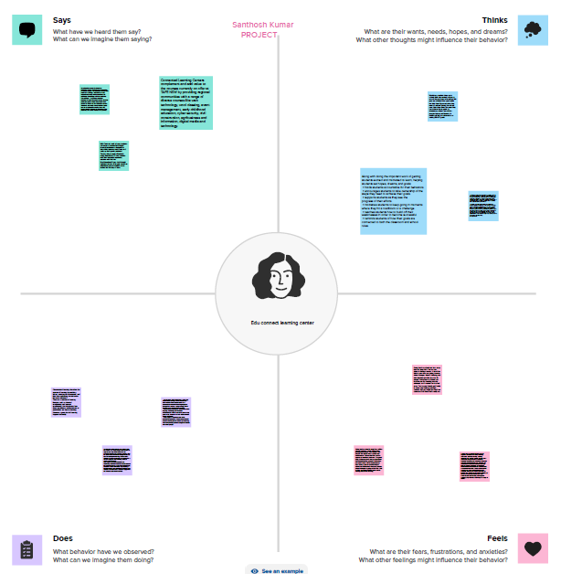

**2.2. IDEATION & BRAINSTORMING MAP**

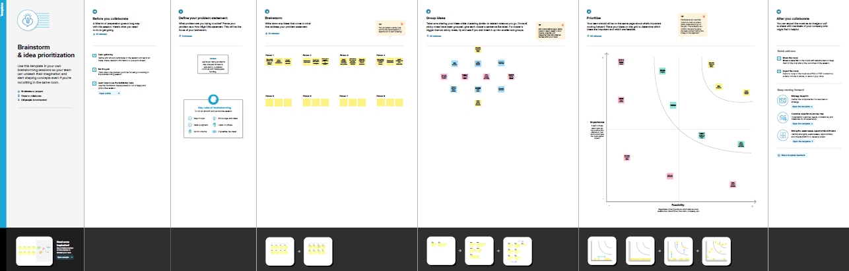

1. **RESULT**

Creating and applying protocols (teaching approaches) that identify solutions to the question or problem.

**Profit & Loss**

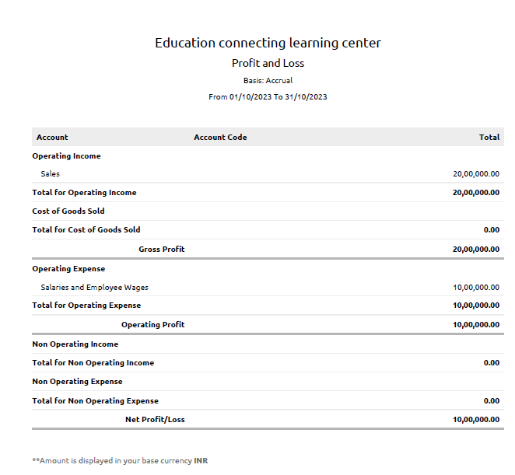

**Balance Sheet**

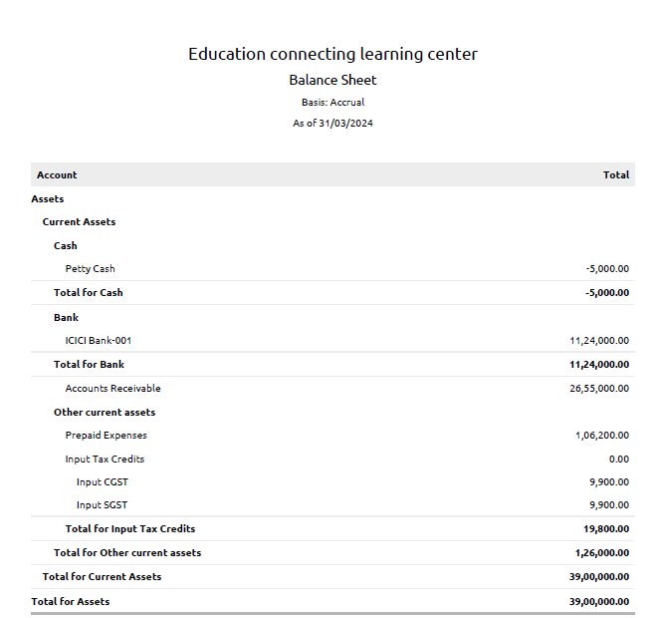

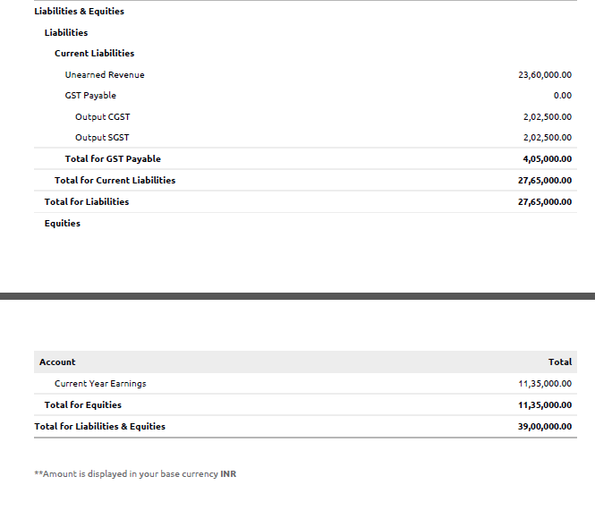

1. **ADVANTAGES & DISADVANTAGES**

**Advantages :** New technological tools not only bring innovation to academic centres, but also speed up the transfer of information, increase student interest, and allow processes to be automated, among other aspects to be taken into account.

* It improves concentration and comprehension. The activities carried out through digital and interactive tools increase student concentration and, therefore, they assimilate concepts more quickly, enhancing learning. This type of tool involves students in more practical learning, with the aim of reinforcing what they have learnt.
* It promotes student flexibility and autonomy. New technologies promote autonomous learning for students. With the incorporation of digital alternatives such as online courses, each student can learn at their own pace, optimising time and resources thanks to the flexibility provided by digitalisation and connectivity.
* It facilitates communication between teachers and students. The whole educational community has quick access to the same resources. In this way, digital tools allow direct and immediate interaction, without the need to be physically present. This was especially important during the confinement experienced during the 2020 health crisis.
* Increased classroom productivity and collaborative work. New technologies in the classroom, specifically those that allow access to online content, improve learning productivity by optimising instruction time, and thanks to connectivity, it feeds collaborative work, thanks to new teaching formulas.

**Disadvantages :** Technologies are not perfect; **just as they bring many benefits to education**, they also have some disadvantages to be taken into account.

* Excessive impact. Excessive and inappropriate use can lead students to a compulsive relationship with technology, which can lead to an inability to control consumption and, consequently, have adverse effects on the student’s health, social, family and academic life.
* It reduces the development of other skills. Practices such as writing, public speaking and reasoning may be nullified by the widespread adoption of digitisation in academic institutions. This has been demonstrated in a recent study conducted by the University of California. The report details that the social skills of the new generations are based on the digital environment, therefore, direct personal communication can be affected.
* Theft of personal data. A lack of knowledge about the dangers of cybercrime can unintentionally expose pupils’ data, especially if they are minors, for example, by sharing photos with strangers.
* It reduces human contact. With the incorporation of new technologies, the learning process becomes more distant and the physical relationship with teachers and classmates decreases. As a consequence, by reducing human contact, isolation can appear and become an obstacle to students’ personal development.

1. **APPLICATIONS**

* Types of education are often divided into levels or stages. The most influential framework is the [International Standard Classification of Education](https://en.wikipedia.org/wiki/International_Standard_Classification_of_Education). It is maintained by the [United Nations Educational, Scientific and Cultural Organization](https://en.wikipedia.org/wiki/United_Nations_Educational,_Scientific_and_Cultural_Organization) (UNESCO). The levels are grouped together into [early childhood education](https://en.wikipedia.org/wiki/Early_childhood_education) (level 0), [primary education](https://en.wikipedia.org/wiki/Primary_education) (level 1), [secondary education](https://en.wikipedia.org/wiki/Secondary_education) (levels 2–3), post-secondary non-tertiary education (level 4), and [tertiary education](https://en.wikipedia.org/wiki/Tertiary_education) (levels 5–8).

* Early childhood education is also known as [preschool education](https://en.wikipedia.org/wiki/Preschool_education) or nursery education. It is the stage of education that begins with birth and lasts until the start of [primary school](https://en.wikipedia.org/wiki/Primary_school).

* Primary (or elementary) education usually starts at the age of five to seven and lasts for four to seven years. It does not have any further entry requirements. Its main goal is to teach the basic skills in the fields of reading, writing, and mathematics. But it also covers the core knowledge in other fields, like [history](https://en.wikipedia.org/wiki/History), [geography](https://en.wikipedia.org/wiki/Geography), the [sciences](https://en.wikipedia.org/wiki/Sciences), [music](https://en.wikipedia.org/wiki/Music), and [art](https://en.wikipedia.org/wiki/Art).

* Secondary education is the stage of education following primary education. It usually covers the ages of 12 to 18 years. It is commonly divided into lower secondary education ([middle school](https://en.wikipedia.org/wiki/Middle_school) or junior high school) and upper secondary education ([high school](https://en.wikipedia.org/wiki/High_school), senior high school, or [college](https://en.wikipedia.org/wiki/College) depending on the country). Lower secondary education normally has the completion of primary school as its entry requirement. It aims to extend and deepen the learning outcomes. It is more strongly focused on subject-specific curricula and teachers are specialized in only one or a few specific subjects.

* Upper secondary education aims to provide students with the skills and knowledge needed for employment or tertiary education. Its requirement is usually the completion of lower secondary education. Its subjects are more varied and complex. The students can often choose between a few subjects. Its successful completion is commonly tied to a formal qualification in the form of a [high school diploma](https://en.wikipedia.org/wiki/High_school_diploma).

* In some countries, tertiary education is used as synonym of [higher education](https://en.wikipedia.org/wiki/Higher_education) while in others, tertiary education is the wider term. It expands upon the foundations of secondary education but has a more narrow and in-depth focus on a specific field or subject.

* Short-cycle tertiary education focuses on practical matters. It includes advanced vocational and professional training to prepare students for the job market in specialized professions. Bachelor's level education is also referred to as [undergraduate education](https://en.wikipedia.org/wiki/Undergraduate_education). It tends to be longer than short-cycle tertiary education. It is usually offered by universities and results in an intermediary academic certification in the form of a bachelor's degree.
* Master's level education is more specialized than undergraduate education. Many programs require independent research in the form of a master's thesis as a requirement for successful completion. Doctoral level education leads to an advanced research qualification, normally in the form of a doctor's degree. It usually requires the submission of a substantial academic work, such as a [dissertation](https://en.wikipedia.org/wiki/Dissertation).

1. **CONCLUSION**

Education develops our personality as well as improves our life condition. Education is that thing once we have in our life nobody can take from us. An investment in knowledge always gives the best interest. In this competitive world having a good education is as important as the air we breathe because it is our weapon to face the world.

In conclusion, education is important in everyone life. Although there are many obstacles for poor people to have education, there should be application of effective solution for the problem of education through which poor people can light their life with education. Education is important to everyone as it gives shape to people’s life; it affects how we act, think, responds and gives path to life. There is always a solution for any problem if anybody truly want to get rid of that problem. It is not easy to have higher education but it is not impossible to get it.

1. **FUTURE SCOPE**

Scope of education means range of view, outlook, field or opportunity of activity, operation and application of education. Education has a wider meaning and application.

**1. Educational Philosophy** **:** Philosophy of education covers aims of education, nature of education, importance of education, function of education its very old and essential part of education.

**2. Educational Psychology :** Main aim of education is the development of child. Psychology helps to understand the child better and development of child with respect of physical, mental, emotional, social adjustment, individual difference, personality, thinking, reasoning, problem solving.

**3. Educational Sociology :** A child lives in the society so it is important for him to know about the society the nature of society, type of society, interdependence between culture and society.

**4. History of Education :**  It is also important to know background, origin, development, growth and aspect of the subjects. And also education system method of teaching during ancient period, medieval period, British period and modern period.

**5. Economics of Education :** For the growth of business and market the world class economical education is important for each and important.

**6. Method of Teaching :** In ancient time the pupil were passive listeners but now they actively participate with the teacher in the process of education. So the skill and proficiency of difference teaching methods needs to be developed.

**7. Educational Administration and Supervision :** The educational institution and the system has to be supervised and administrated smoothly so that the process of education goes well. Regulation of fund, democratic administration, autonomy, personnel management etc.

**8. Problems of Education :** This scope of education includes problems of teaching management of education and also suggestion and remedies for it.

**9. Population Education :** Viewing at the undesirable growth of population, an awareness is created through population education.

**10. Environmental Education :** Ecological in balances have drown the attentions of intelligence today. So looking at the environmental problems study of environment education has great importance.